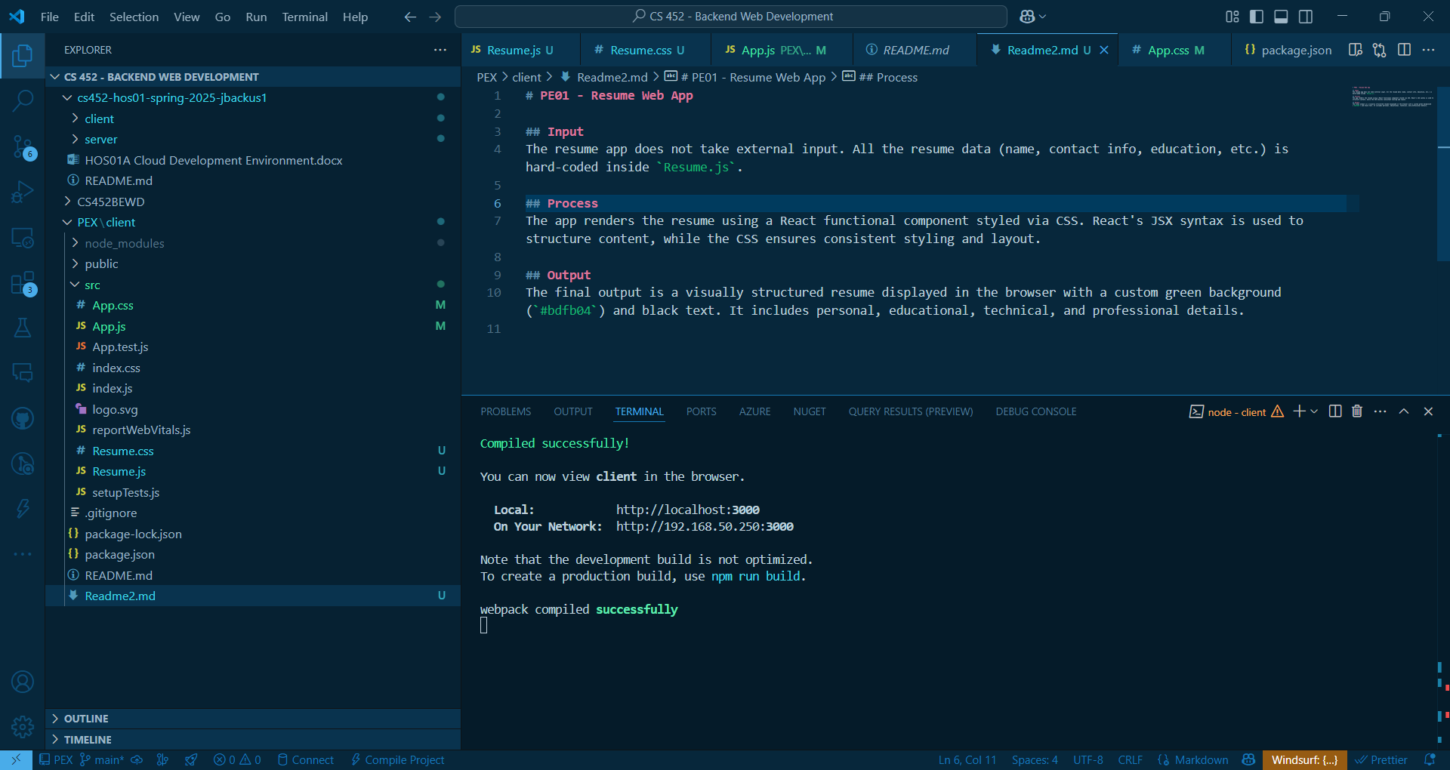

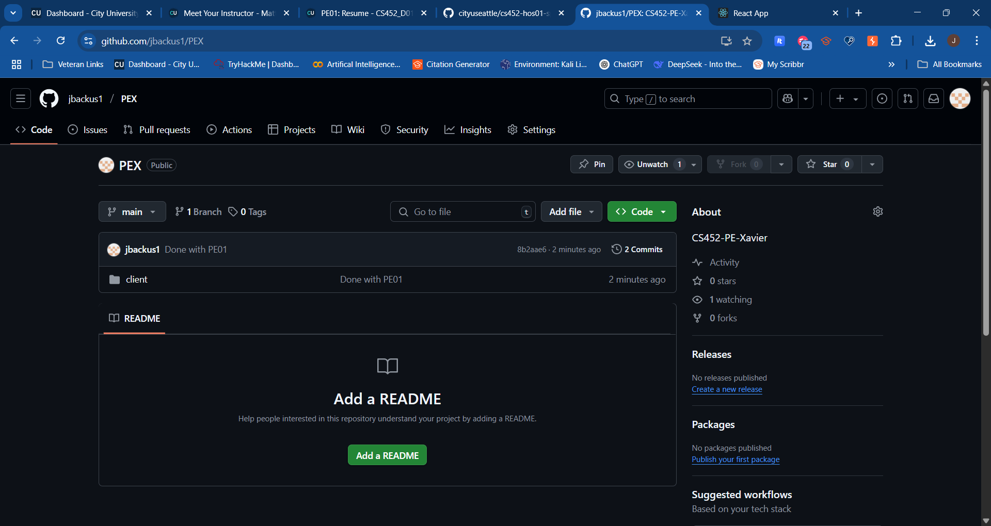

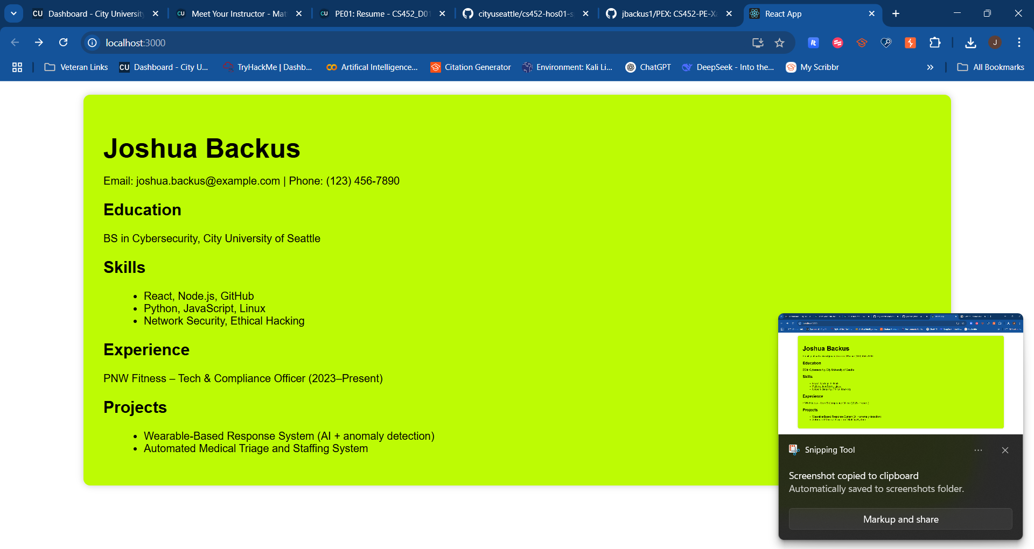

# Input

Users need not apply any input action to operate the resume application. All personal data such as name together with contact information and education history as well as skills list and work history and projects are hard-coded directly within the Resume.js component. All the values function as static display data for the web interface.

# Process

The application implements React as its development framework and operates as a GitHub Codespace application. The Resume.js component serves as the custom visual element which Resume.css provides the styling functionality for. Content organization occurs in the component through HTML-like JSX syntax while static elements obtain their styling characteristics from font, margin, padding and background color settings matching the assignment parameters. The app maintains a modular structure which divides structure from design elements to improve maintenance efficiency.

# Output

The browser shows a resume with green(?) background (#bdfb04) and black text during rendering. The panel possesses a systematic structure whereby Education, Skills, Experience and Project sections demonstrate distinct readability features. Every visual requirement for design in the application operates effectively.